1.1 Jerry and Susan have a joint bank account.Jerry goes to the bank 20% of the days.Susan goes there 30% of the days.Together they are at the bank 8% of the days.

a.Susan was at the bank last Monday. What’s the probability that Jerry was there too?

**P(Jerry at the bank | Susan at the bank) = 8%/30% = 26.7%**

b.Last Friday, Susan wasn’t at the bank. What’s the probability that Jerry was there?

**P(only Jerry at the bank | Susan wasn’t at the bank) = 12% / 70% = 17.14%**

c.Last Wednesday at least one of them was at the bank. What is the probability that both of them were there?

**P(both of them at the bank | at least one at the bank) = 8% /(20% +30% -8%) = 19.05%**

1.2 Harold and Sharon are studying for a test.Harold’s chances of getting a “B” are 80%. Sharon’s chances of getting a “B” are 90%.The probability of at least one of them getting a “B” is 91%.

a.What is the probability that only Harold gets a “B”?

**P(H) = 80% P(S) = 90% P(H) +P(S) – P(H∩S) = 91%**

**P(H∩S) = 79%**

**P(H) - P(H∩S) = 1%**

b. What is the probability that only Sharon gets a “B”?

**P(S) – P(H∩S) = 11%**

c. What is the probability that both won’t get a “B”?

**1-( P(H) +P(S) – P(H∩S)) = 9%**

1.3Jerry and Susan have a joint bank account.Jerry goes to the bank 20% of the days.Susan goes there 30% of the days.Together they are at the bank 8% of the days.Are the events “Jerry is at the bank” and “Susan is at the

bank” independent?

**A and B are independent (no additional information) if:P(A∩B)) = P(A)P(B)**

**If the events “Jerry is at the bank” and “Susan is at the bank” are independent, P(J∩S)) = P(J)P(S) = 6% ,not equal to 8%, so the events are dependent.**

1.4 You roll 2 dice.

a.

Are the events “the sum is 6” and “the second die shows

5” independent?

**X (the sum is 6) = {(1,5),(5,1),(2,4),(4,2),(3,3)}**

**P(X) = 5/36**

**Y(the second die shows5) = {(1,5), (2,5), (3,5), (4,5), (5,5), (6,5)}**

**P(Y) = 6/36**

**P(X∩Y) = P(1,5) / 6 * 6 = 1/36**

**P(X) P(Y)=30 / 36^2 , not equal to 1/36, so the events are dependent.**

b. P(Y)

Are the events “the sum is 7” and “the first die shows 5”

independent?

**X (the sum is 7) = {(1,6),(6,1),(2,5),(5,2),(3,4),(4,3)}**

**P(X) =6/36**

**Y(the first die shows 5) = {(5,1),(5,2),(5,3),(5,4),(5,5),(5,6)}**

**P(Y) = 6/36**

**P(X∩Y) = P (5,2) /6 * 6 = 1/36**

**P(X) P(Y) = 1/36, so the events are independent.**

1.5 An oil company is considering drilling in either TX, AK and NJ. The company may operate in only one state. There is 60% chance the company will choose TX and 10% chance NJ.

There is 30% chance of finding oil in TX, 20% in AK, and 10% in NJ.

1. What’s the probability of finding oil?

**P(choose AK) = 30%**

**(chooseTX) ∪ (chooseAK)∪ (chooseNJ) = Ω**

**P(finding oil) = P(finding oil | chooseTX) P(choose TX) + P(finding oil | chooseAK) P(choose AK)+ P(finding oil | chooseNJ) P(choose NJ) = 30%*60% + 20%*30% +10%*10% = 25%**

2.The company decided to drill and found oil. What is the probability that they drilled in TX?

**P(drilled in TX | finding oil) = P(chooseTX ∩ finding oil in TX) / P(finding oil) =30%*60% / 25% = 72%**

1.6

The following slide shows the survival status of individual passengers on the Titanic . Use this information to answer the following questions

■ 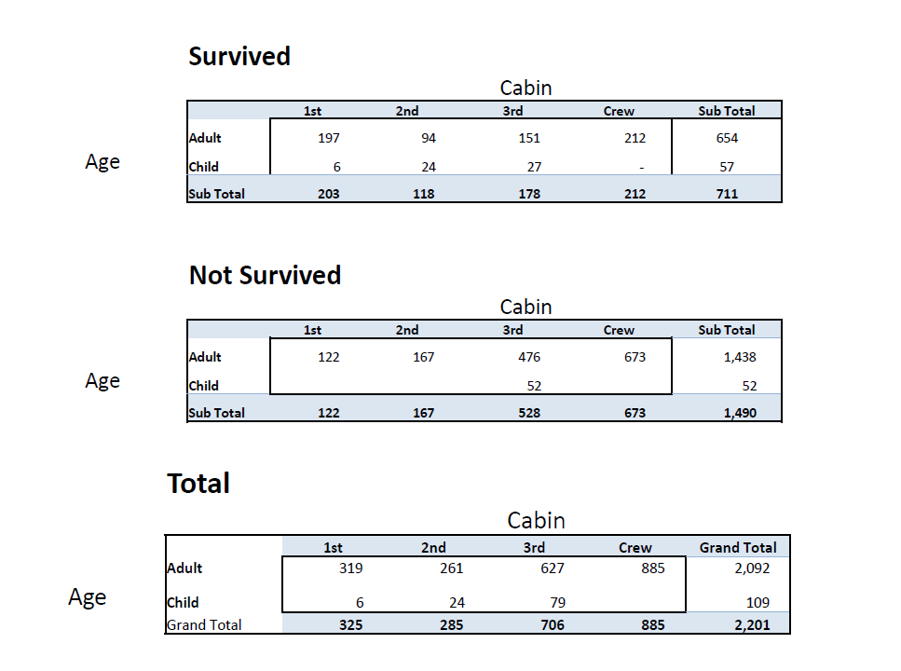

1.What is the probability that a passenger did not survive?

**P(did not survive) = 1490 / 2201 = 67.7%**

2.What is the probability that a passenger was staying in the first class?

■ **P(a passenger was staying in the first class) =325 / 2201 = 14.8%**

3.Given that a passenger survived , what is the probability that the passenger was staying in the first class?

■ **P(a passenger was staying in the first class | survived) = (203 / 2201) /(711 / 2201) = 28.6%**

4.Are survival and staying in the first class independent

■ **P(a passenger was staying in the first class) P(survived) = 14.8% * 32.3% = 4.77%,P(a passenger was staying in the first class ∩ survived) = 203/2201 = 9.22%, They are not equal, so the events are dependent**.

5.Given that a passenger survived , what is the probability that the passenger was staying in the first class and the passenger was a child?

**P(child ∩ 1st class ∩ survived | survived) = (6 / 2201) / (1 – 67.7%) = 0.84%**

6.Given that a passenger survived , what is the probability that the passenger was an adult?

■ **P(adult ∩ survived | survived) = (654 /2201) /（711 / 2201）= 91.98%**

7.Given that a passenger survived , are age and staying in the first class independent?

**P(adult ∩1st class ∩ survived ) = 197 / 2201 = 8.95%**

**P(adult ∩ survived ) P(1st class ∩ survived ) = (654 /2201) * (203/2201) = 2.74%**

**P(child ∩1st class ∩ survived ) = 6 / 2201= 0.27%**

**P(child ∩ survived ) P(1st class ∩ survived ) = (57 /2201) * (203/2201) = 0.24%**

**They are not equal, so the events are dependent.**